Access to Visual Studio Teams Services has been set up for everyone on this e-mail thread.  If you have any issues with access please contact either Steven J. Moe [Steven.Moe@PreceptConsulting.com](mailto:Steven.Moe@PreceptConsulting.com) or [julie.m.giese@wellsfargo.com](mailto:julie.m.giese@wellsfargo.com) and one of us will try to help.

Access to Visual Studio Teams Services and TFS Source Control  has been set up with Basic access for

Rich Wolf <[richwlf4@gmail.com](mailto:richwlf4@gmail.com)>;

Derek Spencer <[derek@lakesarah.com](mailto:derek@lakesarah.com)>;

Kincaid <[kincaidrowbotham.net@gmail.com](mailto:kincaidrowbotham.net@gmail.com)>.

Drake Meyer <[xxglxxthedr@gmail.com](mailto:xxglxxthedr@gmail.com)>;

A J Giese <[aj.giese17@gmail.com](mailto:aj.giese17@gmail.com)>;

[julie.m.giese@wellsfargo.com](mailto:julie.m.giese@wellsfargo.com)

Christian Eidahl [ceidahl98@gmail.com](mailto:ceidahl98@gmail.com)

Steven J. Moe <[Steven.Moe@PreceptConsulting.com](mailto:Steven.Moe@PreceptConsulting.com)>;

[Moexx399@d.umn.edu](mailto:Moexx399@d.umn.edu); (Brandon)

[Harrison.bolzer@gmail.com](mailto:Harrison.bolzer@gmail.com)

Todd Bolzer <[htbolzer@gmail.com](mailto:htbolzer@gmail.com)>;

Nathan Moe <[nmoe1999@gmail.com](mailto:nmoe1999@gmail.com)>;

Alex Moe <[alexmoe1999@gmail.com](mailto:alexmoe1999@gmail.com)>;

Wyatt Duberstein [wyattduber@gmail.com](mailto:wyattduber@gmail.com)

<https://preceptconsulting.visualstudio.com/>

<https://preceptconsulting.visualstudio.com/FRC%203026/_home?welcome=true>

Team team members Parrents only need to set up Microsoft account with e-mail address used below and then access the Team services site at

<https://preceptconsulting.visualstudio.com/>

<https://preceptconsulting.visualstudio.com/FRC%203026/_home?welcome=true>

FRC Team members have also been set up with Stakeholder access for

Calvin Wolf [swolfce@gmail.com](mailto:swolfce@gmail.com)

Brett Bolzer [brett.bolzer@gmail.com](mailto:brett.bolzer@gmail.com)

Stakeholder access has been set up for Parents

Cindy Moe ([Cindy.Moe@PreceptConsulting.com](mailto:Cindy.Moe@PreceptConsulting.com))

Lucia Williams [lucia@jenux.net](mailto:lucia@jenux.net)

Lynn Eidahl [lynngeidahl@gmail.com](mailto:lynngeidahl@gmail.com)

Lyle Meyer [lyle.meyer@gmail.com](mailto:lyle.meyer@gmail.com)

Shelby Wolf [swolf@westmetrofire.com](mailto:swolf@westmetrofire.com)

Create Microsoft Account.  Send your e-mail address used to create that account to Steve Moe ([StevenM@PreceptConsulting.com](mailto:StevenM@PreceptConsulting.com))  so you can be added to the Source Control and source control project.

<https://account.microsoft.com/about?refd=www.bing.com>

Follow instructions to create this account.

Once you have been added, Access site below to make sure you have correct access to project and site.

1.       Link to web version <https://preceptconsulting.visualstudio.com/FRC%203026/_home?welcome=true>   Will need to set up Microsoft Login using e-mail password combination.

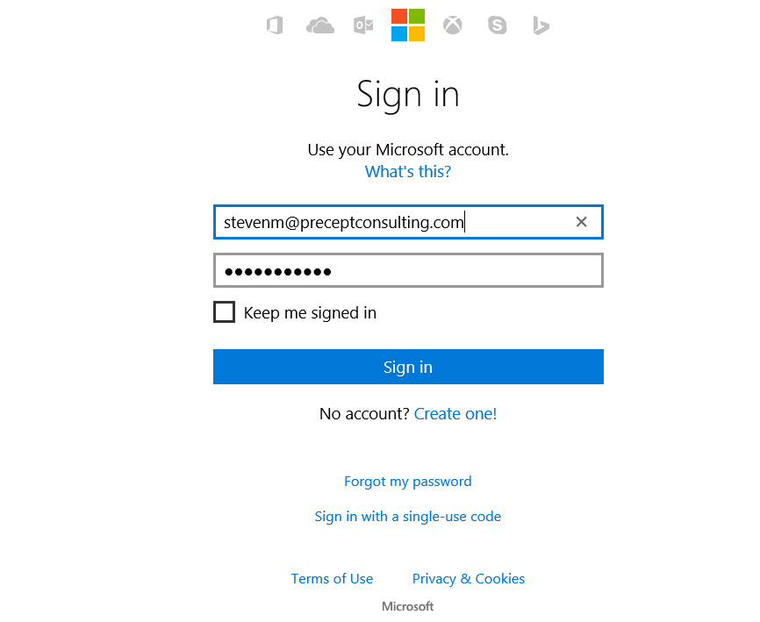

The links below will work to install all software needed.  Source control software instructions have been included in this e-mail.

1.       <http://ftp.ni.com/support/softlib/labview/labview_frc/NI_FRC2016_downloader.exe>

a.       This is the download page for NI Software for 2016. This includes LabVIEW 2015 and other software needed to program for the FRC 2016 competition. You must also download and install the 2016 Update Suite to program for FRC 2016.

b.       Download and unzip NI_FRC2016.zip 2. Run setup.exe

c.       The link <https://decibel.ni.com/content/docs/DOC-46527>  gets you to the download and install instructions for the file in step1 if you need details or the direct link does not work.

2.       <http://ftp.ni.com/support/softlib/first/frc/FileAttachments/FRCUpdateSuite_2016.1.0_downloader.exe>

a.       The FRC 2016 Update Suite is a mandatory update for all FRC teams. Teams using LabVIEW must first install the NI Software for FRC 2016 included in the FRC Kit of Parts prior to installing this update.

b.       Log on as an administrator or as a user with administrator privileges. 2. Download the file from above and extract the zip file. 3. Double-click setup.exe and follow the instructions that appear on the screen. You must activate this software with your FRC team serial number after kickoff. The serial number can be found with the NI Software for FRC 2016 DVD packaging found in your FRC Kit of Parts.

c.       The link <https://decibel.ni.com/content/docs/DOC-46527>  gets you to the download and install instructions for the file in step2 if you need details or the direct link does not work.

3.       <http://www.kauailabs.com/public_files/navx-mxp/navx-mxp-libs.zip>

a.       Unzip this file and we will have you move this to a special directory for the current competition code.  Direction to be provided later.

b.       <http://www.kauailabs.com/public_files/navx-mxp/> gets you to the download where this zip file exists in step3 the direct link does not work.

The activation code for Labview 2015\2016 with updates is M81X06513.  You will need it to activate the software.  This is specific and confidential for team 3026.  **Please do not share it with anyone not on the team.**

Email Todd Bolzer  Todd Bolzer [htbolzer@gmail.com](mailto:htbolzer@gmail.com) or Steve Moe  Steven J. Moe [Steven.Moe@PreceptConsulting.com](mailto:Steven.Moe@PreceptConsulting.com)  if you have problems or questions.  This software license expires Jan 1, 2017.

Steps to Add Source Control to Labview.

If you cannot get each of the tools loaded, at least get each of the downloads on your computer and perform the base install of those components.  We can assist on getting your computer configured after all components are installed.

Some of these downloads can take some time depending on your internet connection speed.

No we need to install some software on your desktop or laptop to use with Labview for source code control.

2.      <https://www.microsoft.com/en-us/download/details.aspx?id=40776>   Download and install.

3.      <https://visualstudiogallery.msdn.microsoft.com/06c8e056-7f77-4a5c-9b8b-49318c143df8>   Download and install.

a.     Set Connection to <https://preceptconsulting.visualstudio.com/>

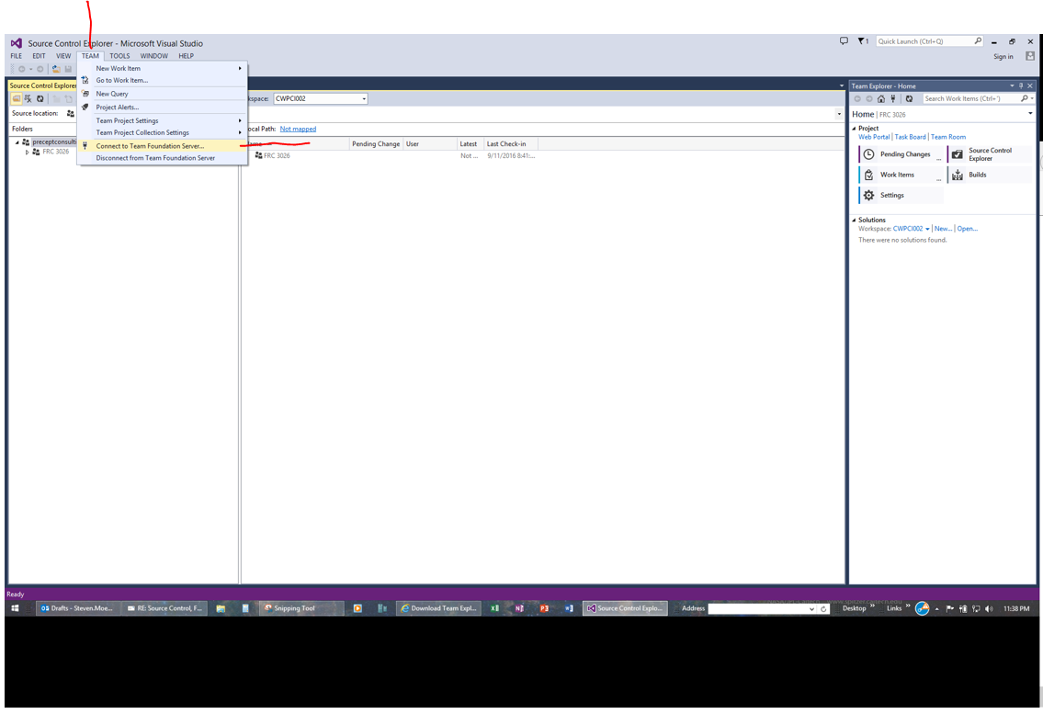

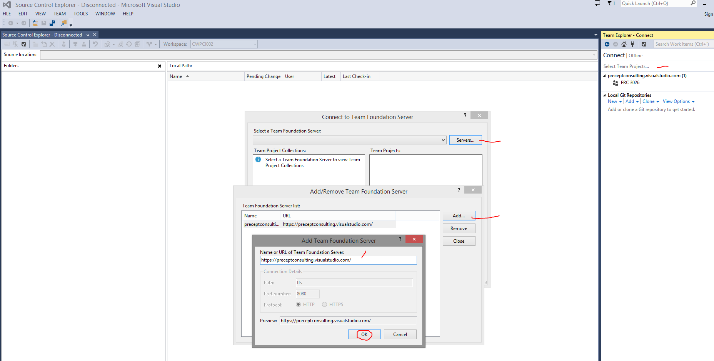

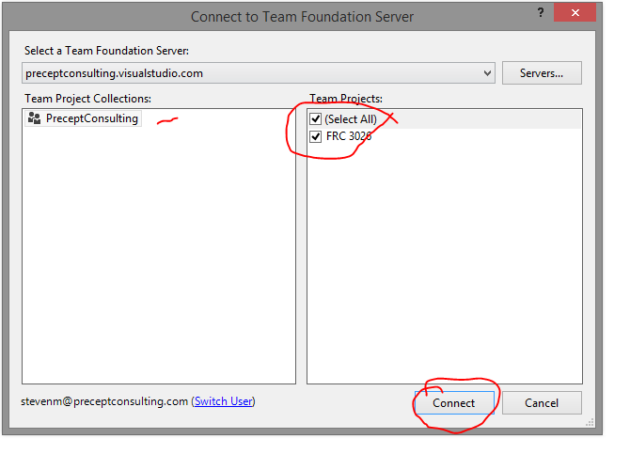

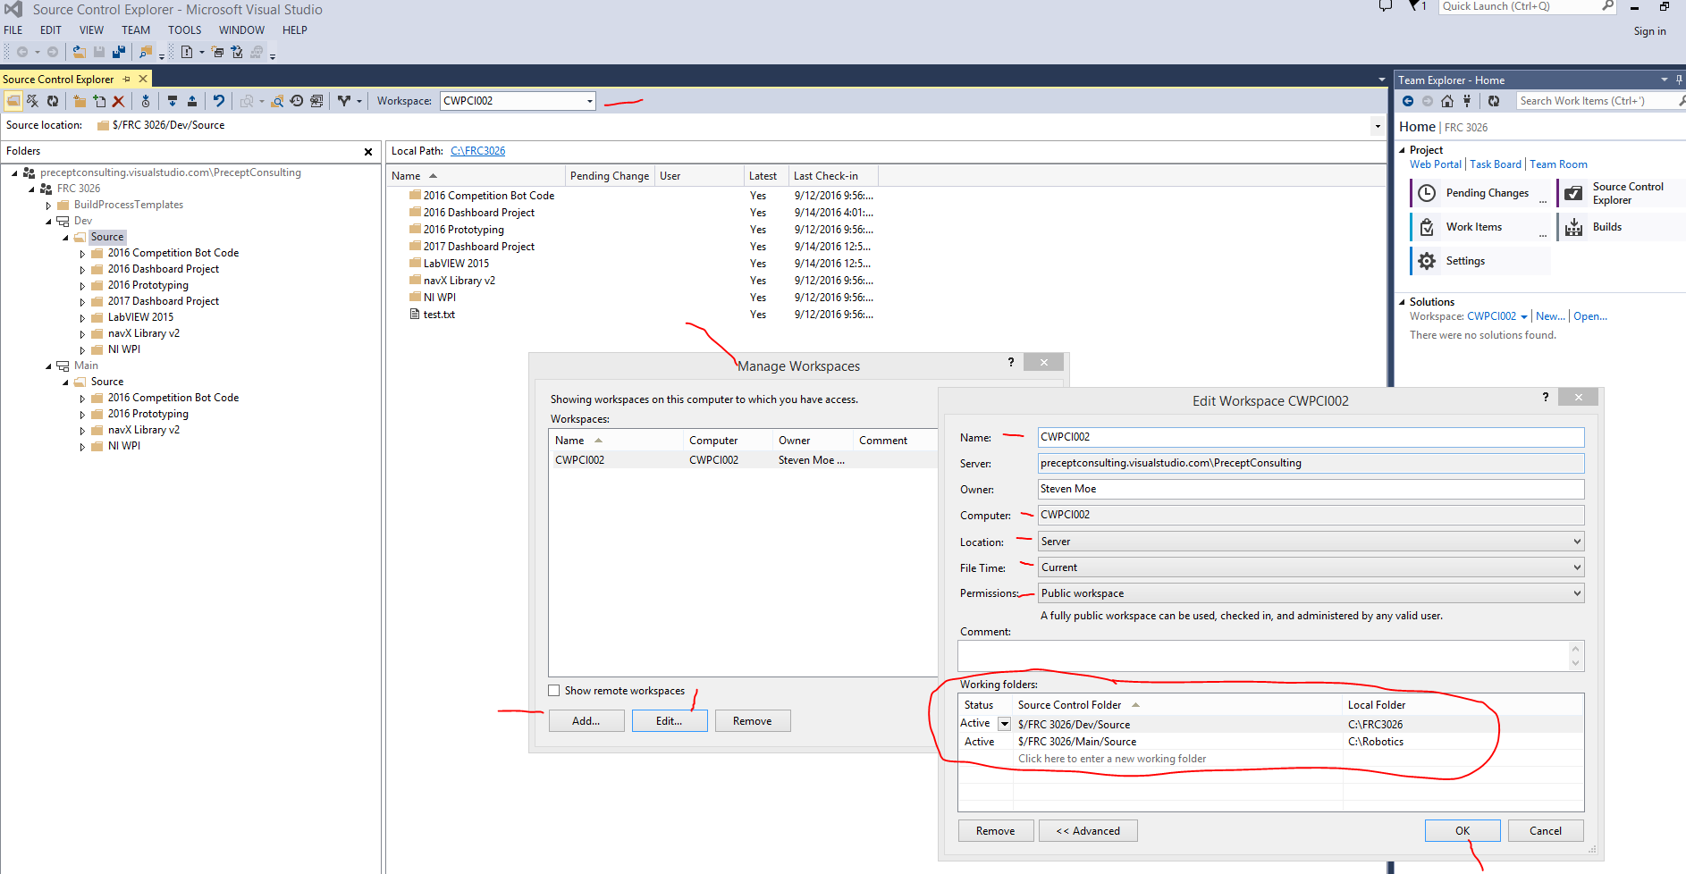

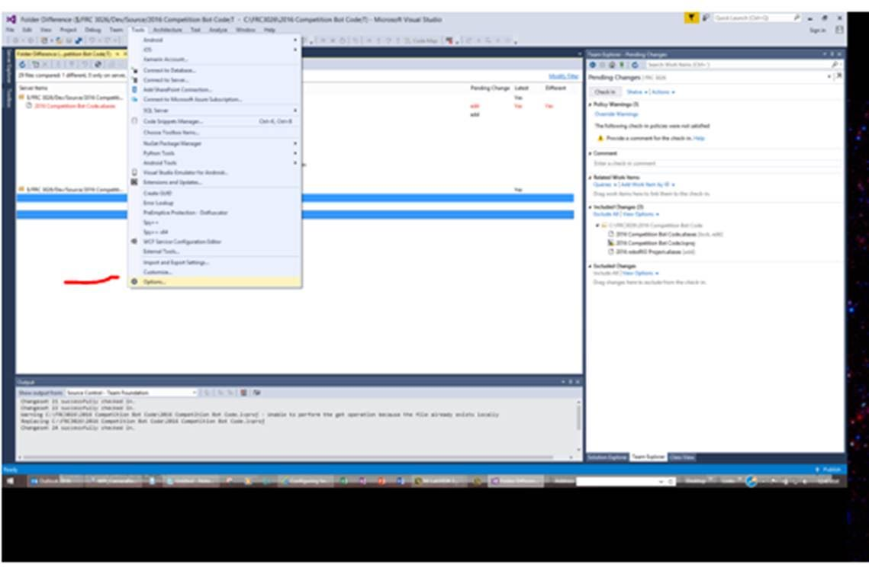

Command = C:\Program Files\National Instruments\Shared\LabVIEW Compare\LVCompare.exe

Arguments = %1 %2 -nobdcosm -nobdpos -nofppos

This will use the LabView compare program for .VI files.  If we need to add any other file types with this compare, add them to the extensions list comma delimited.

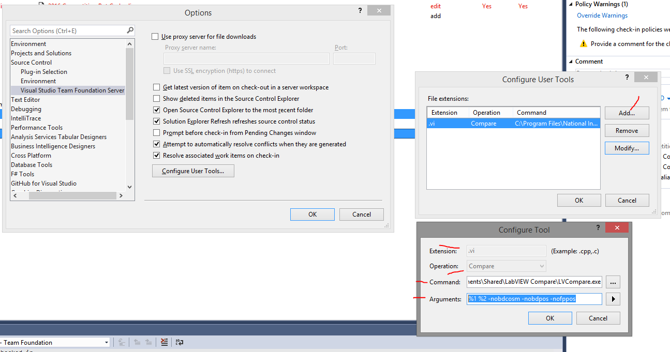

4.      In Labview set up tools\options\source control

a.       Select

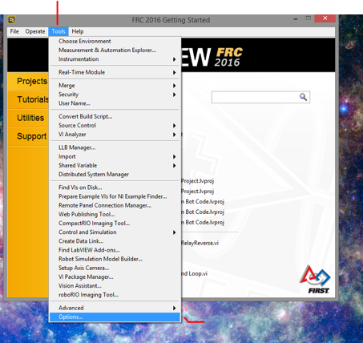

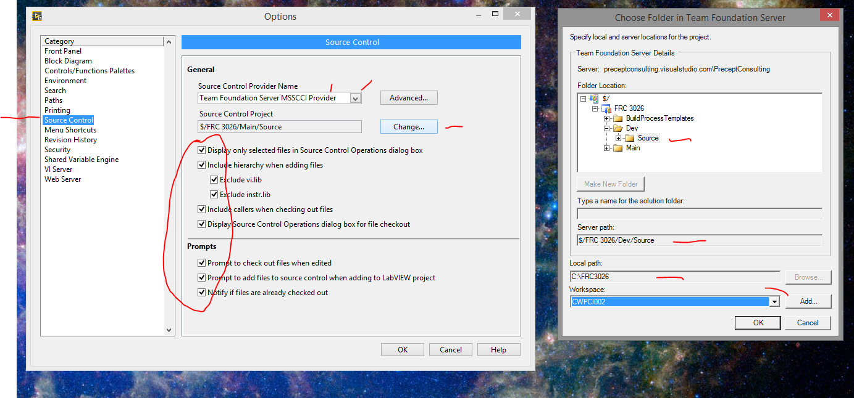

5.      <https://go.microsoft.com/fwlink/?LinkId=691978&clcid=0x409>  Download and install Visual Studio 2015 software unless you already have it installed.  Save file in link to local disk and execute file.  This will install Visual Studio 2015  Community Version.

Set up source control for this version the same way that source control was set up in Visual Studio 2013.